**PSP Estimation Worksheet**

1. Conceptual Design

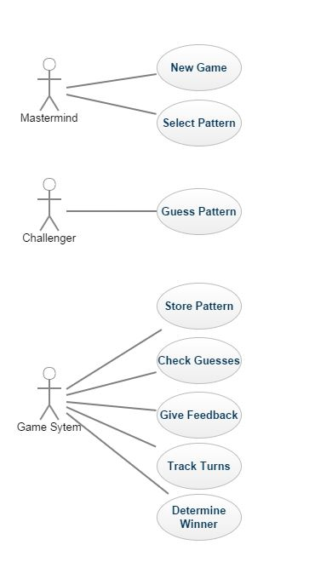

1. Module Estimate

|  |  |
| --- | --- |
| **Module** | **Estimated LOC** |
| Mastermind | 60 |
| Challenger | 40 |
| Game System | 250 |
| IO | 50 |
|  |  |
| Total | 400 |